BASIC SYSTEM INVESTIGATION – POWERSHELL

Task 1 – Identify the Current Logged-in User *
Scenario
A SIEM alert indicates that a suspicious PowerShell command was executed on a Windows endpoint.
Objective
Identify the user currently logged into the system.
Command
Whoami
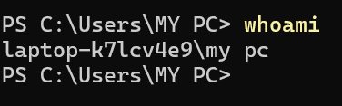
Expected Output
desktop-01\john
SOC Perspective
A SOC analyst verifies the user account associated with the security alert.
Why is this important?
- Identify the affected user.
- Verify whether the account is expected.
- Detect unauthorized or privileged account usage.
Suspicious Indicators
- Administrator account logged in unexpectedly.
- Service account used interactively.
- Unknown user account.

Task 2 – Identify the Hostname *
Scenario
SIEM Alert
Malware detected on HOST-FINANCE-23
Objective
Confirm that you are investigating the correct endpoint.
Command
Hostname
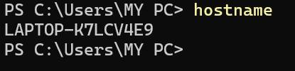
Expected Output
HOST-FINANCE-23
SOC Perspective
Before starting an investigation, analysts always verify the endpoint identity.
Why?
Investigating the wrong endpoint wastes valuable response time.

Task 3 – Collect System Information *
Objective
Gather complete operating system information.
Command
Get-ComputerInfo
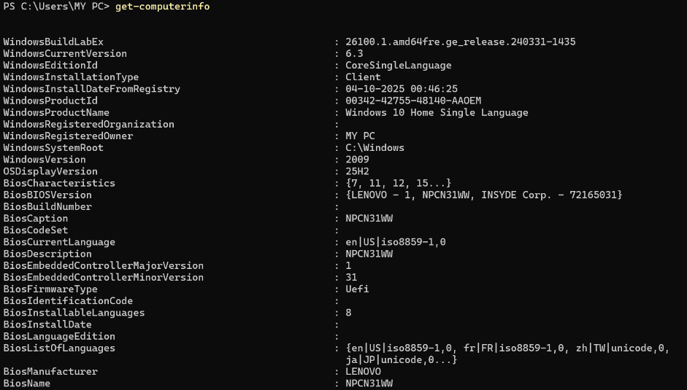
Important Fields
- Windows Version
- OS Build
- Install Date
- BIOS Version
- Total Physical Memory
- Domain Name
SOC Perspective
Older operating systems may contain known vulnerabilities and missing security patches.
Suspicious Indicators
- Unsupported Windows version
- Missing security updates
- Unexpected domain membership

Task 4 – Check PowerShell Version *
Command
$PSVersionTable
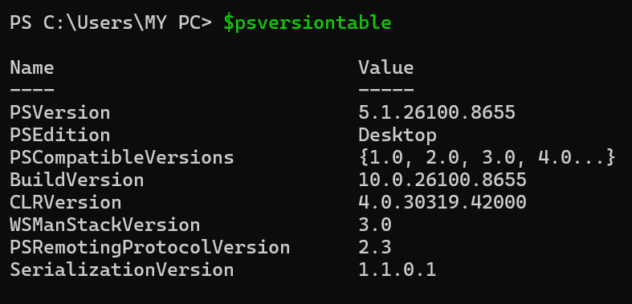
SOC Perspective
Attackers frequently abuse PowerShell.
Knowing the installed PowerShell version helps determine available attack techniques and logging capabilities.
Look For
- PowerShell Version-version hai powershell ka
- PSEdition- type of machine jisme chakra hai (desktop)
- CLR Version- engine at backend responsible for command run
- Build version- windows ka version

Task 5 – Identify Current Working Directory *
Command
Get-Location

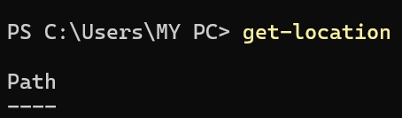
Expected Output
Path
----
C:\Users\John
SOC Perspective
Determine where scripts or commands are being executed.
Suspicious Indicators
Execution from:
AppData
Temp
Public
Downloads
instead of trusted locations.

Task 6 – Check Current Date and Time
Command
Get-Date
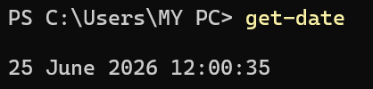
SOC Perspective
Essential for incident timeline analysis.
SOC analysts correlate timestamps with:
- Event Logs
- SIEM Alerts
- EDR Events

Task 7 – Check PowerShell Execution Policy *
Command
Get-ExecutionPolicy
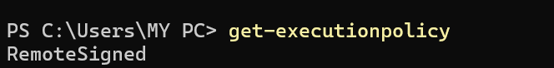
Possible Output
Restricted koi script run nahi honsakti only commands
RemoteSigned script jo locally created run and from download only trusted publisher
AllSigned script signed by trusted publisher
Bypass nothing is blocked
Unrestricted can run all script but always get warming for unsigned script from download
SOC Perspective
Execution Policy controls PowerShell script execution.
Suspicious Indicators
Bypass
Unrestricted
Attackers often modify the execution policy to execute malicious scripts.

Task 8 – Display Environment Variables *
Command
Get-ChildItem Env:
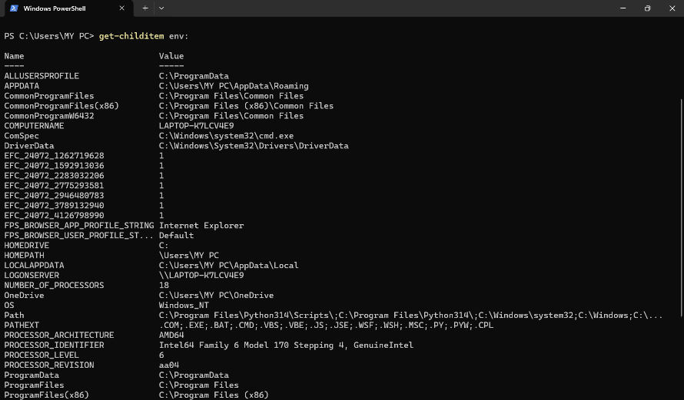
SOC Perspective
Environment variables can reveal:
- Username
- Computer Name
- Temporary directories
- System paths
Malware may abuse these variables.

Task 9 – Display Computer Name (hostname)
Command
$env:COMPUTERNAME
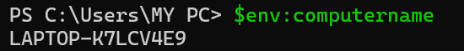
SOC Perspective
Frequently used in automation scripts and investigation reports.

Task 10 – Display Username (whoami)
Command
$env:USERNAME
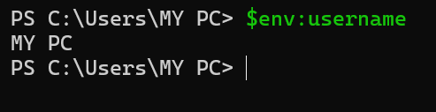
SOC Perspective
Useful for quickly identifying the active user without running additional commands.

Task 11 – Identify Domain Membership *
Command
(Get-CimInstance Win32_ComputerSystem).Domain
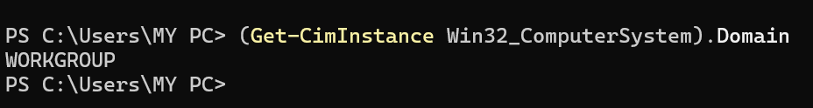
SOC Perspective
Determine whether the endpoint belongs to:
- Active Directory domain
- Workgroup
- Azure AD
Compromised domain-joined systems require immediate attention.
Aggar computer joined hota kisy organization ya company se then I will show contoso.com

Task 12 – Check System Uptime *
Command
(Get-CimInstance Win32_OperatingSystem).LastBootUpTime
SOC Perspective
Useful during incident response.
Questions answered:
- Was the system recently rebooted?
- Did malware survive a reboot?
- Did an attacker reboot the system?

Task 13 – Retrieve BIOS Information
Command
Get-CimInstance Win32_BIOS

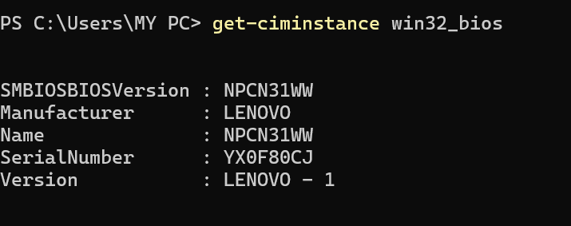
SOC Perspective
Useful for:
- Asset inventory
- Hardware identification
- Incident documentation
  - Serial number – like laptop id
  - Version :Lenovo 1- hardware release

Task 14 – Display Processor Information
Command
Get-CimInstance Win32_Processor
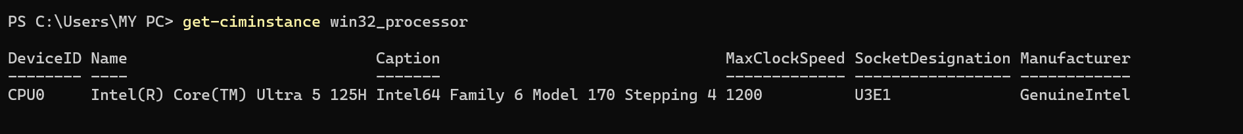
SOC Perspective
Collect host hardware details during investigations.
- Ek to yeh processor (cpu) ke baare mai battaraha hai
- Socket designation- yeh vo jagah hai jaha par mother board par processor fit hota hai

Task 15 – Display Physical Memory
Command
Get-CimInstance Win32_PhysicalMemory
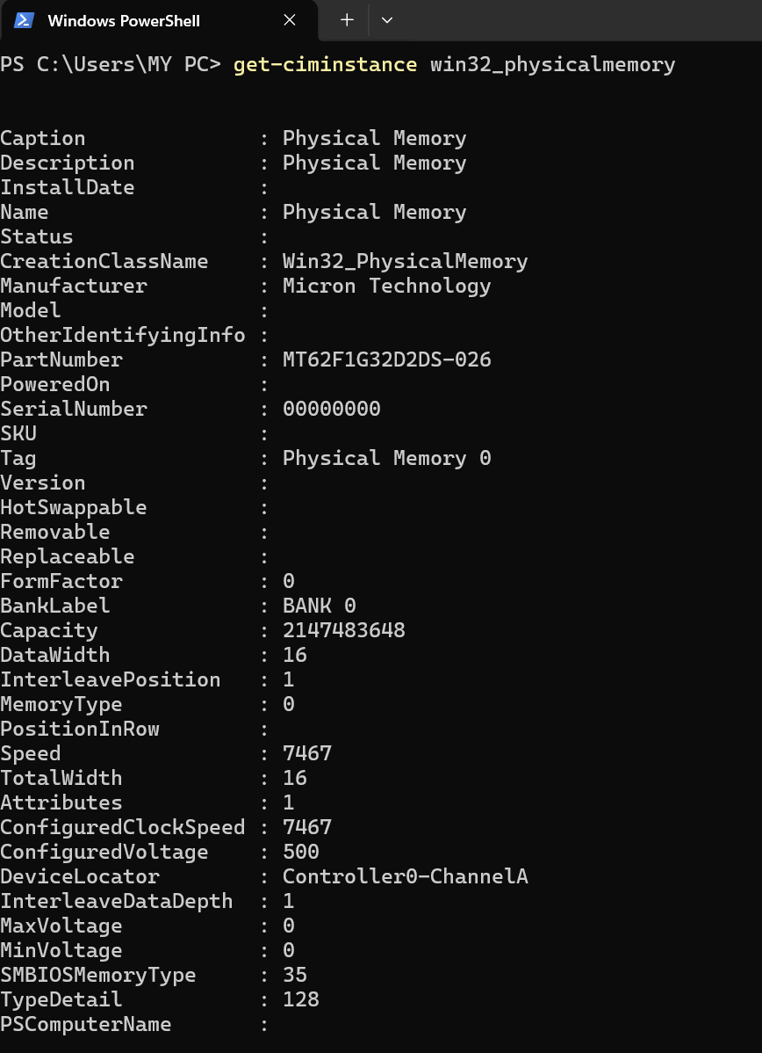
SOC Perspective
Memory size is useful when planning memory acquisition or forensic analysis.

Task 16 – List Available Drives
Command
Get-PSDrive
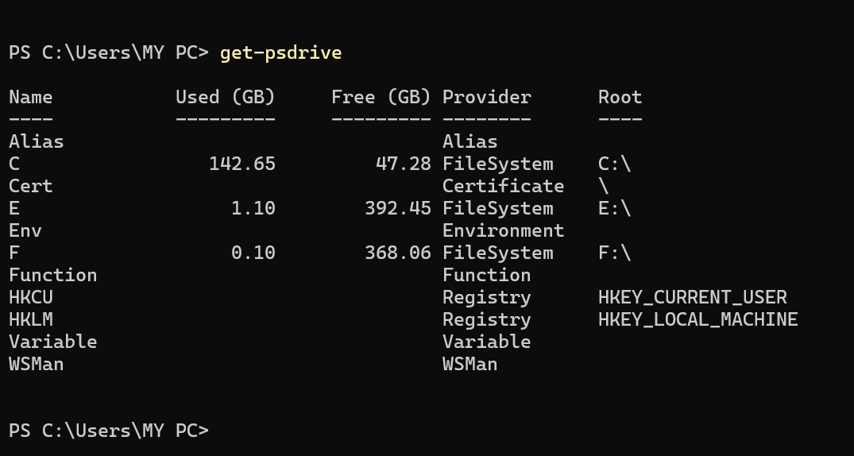
SOC Perspective
Identify all logical drives that may contain evidence.
- C,E,F yeh saari drives hai jaha file save hoti hai
- Hkcu,hklm yeh register configrational path hai

Task 17 – Display Operating System Details *
Command
Get-CimInstance Win32_OperatingSystem | fl *
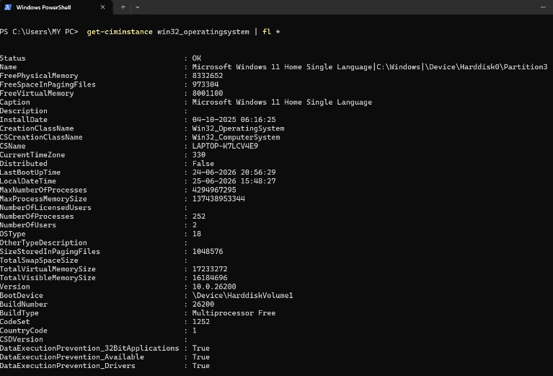
SOC Perspective
Collect OS information for vulnerability assessment.
Dep- it protect against malicious data execution
Encryption level- tell how much encryption active on system
Muilanguage- basically system local languge

Task 18 – Display Logged-in Sessions
Command
quser
SOC Perspective
Identify:
- Active users
- Remote Desktop sessions
- Multiple logged-in users
Unexpected sessions may indicate unauthorized access.

Task 19 – Display Computer Manufacturer
Command
Get-CimInstance Win32_ComputerSystem
s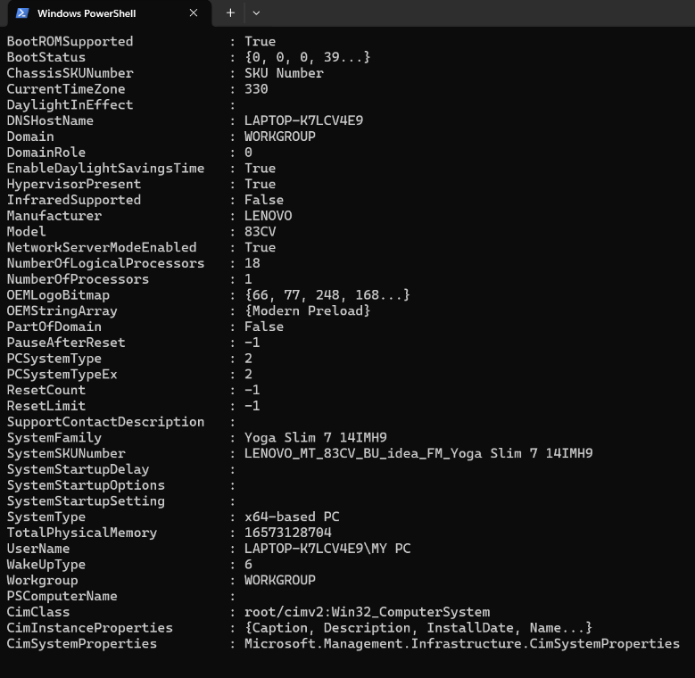
SOC Perspective
Useful for endpoint inventory and documentation.

Task 20 – Save Investigation Results
Command
Get-ComputerInfo > SystemInfo.txt
SOC Perspective
SOC analysts often export investigation results as evidence for incident reports.

